**Weather Application Deployment into kubernetes Cluster**

1. Weather application development is done by using React.js
2. Once application is developed you can test application in your local, Using below steps
3. Open CMD in your local and clone your git repo which has code in that

git clone <https://github.com/ronakbhatt3145/kubernetes.git>

1. After cloning need to go that folder and run “npm install and npm start”(In your local node.js and git has be installed)

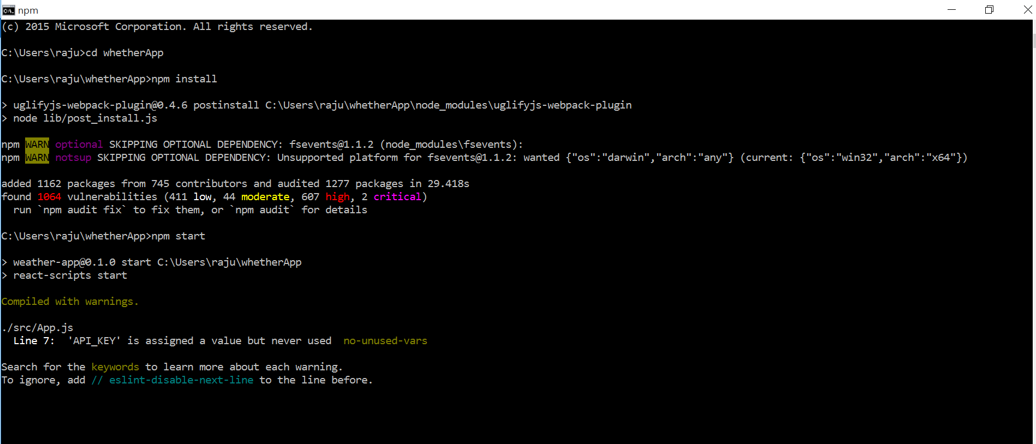

1. Application can access with localhost:3000

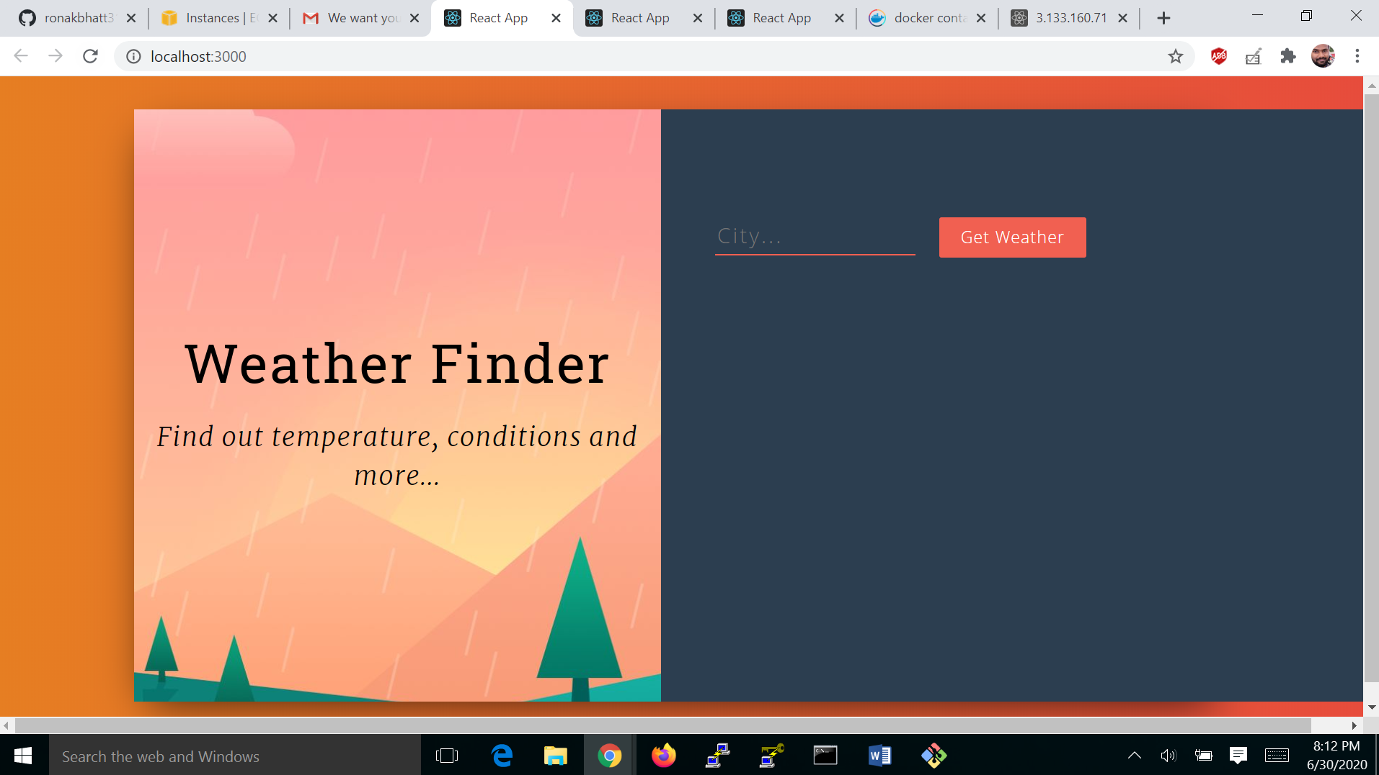

1. Same steps you can follow in AWS instance also you can access application with InstanceIP and port number

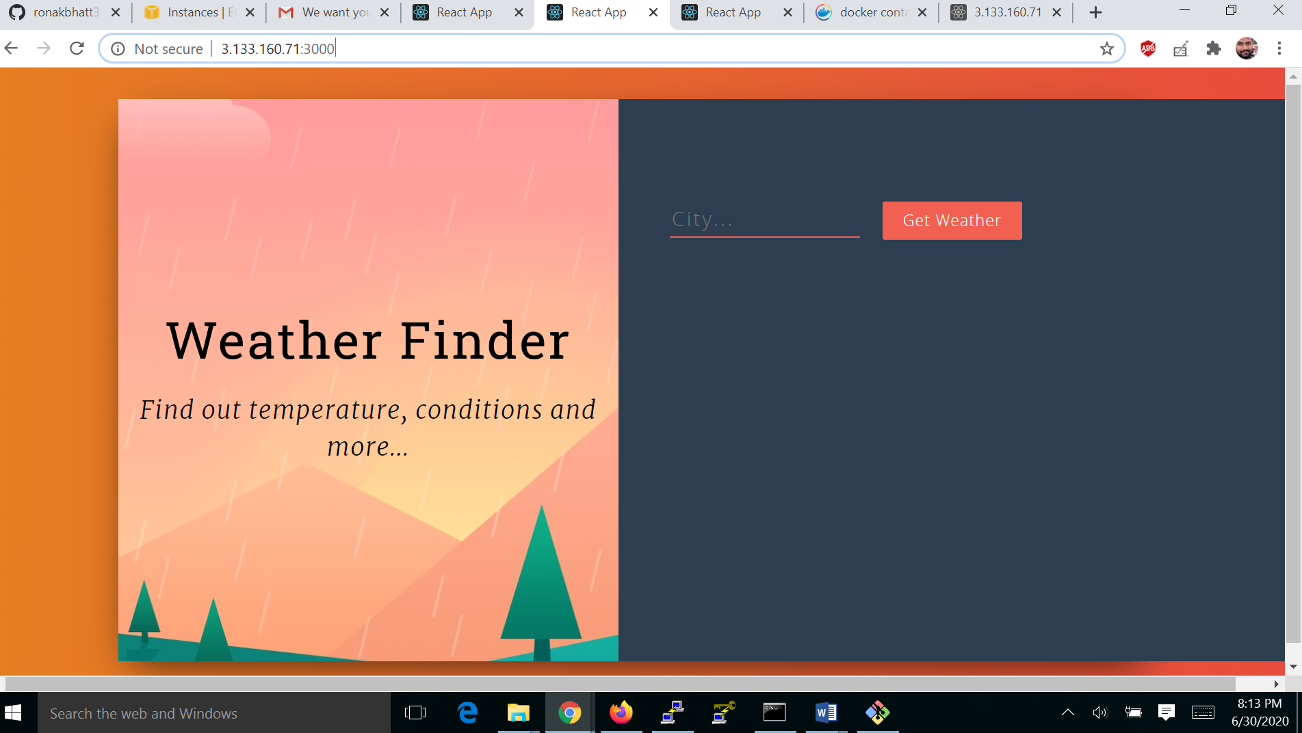

1. After application is developed need to right Dockerfile, file is present in git repo
2. By using Dockerfile need to build image from that code

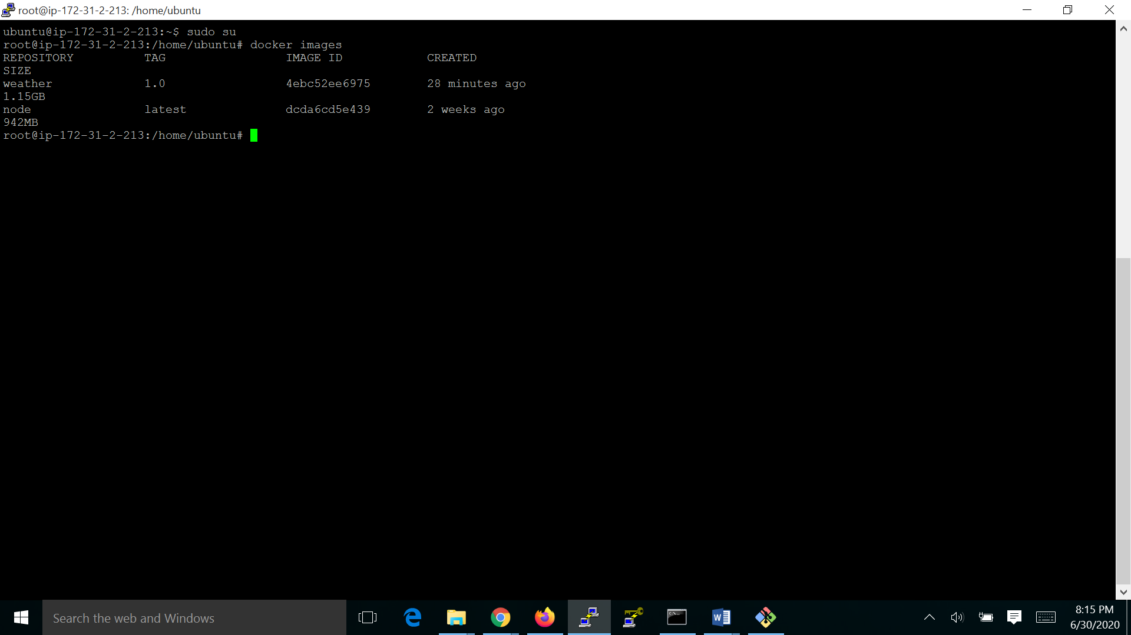

1. Docker image we need to deploy into kubernetes cluster so that we can access your application by using Nodeport service type in kubernetes.(i.e:nodeIP:3000),deployment and service files are present in git repo